
Department of Artificial Intelligence and Machine Learning

Course Name | Service Learning
Name of Student | Priyansh Pandey
PRN No. | 24070126143
Class | AIML – B
Academic Year & Semester | 2026-2027 & Semester -5
15 days duration of work done
  Dates | Time
  03/09/2026 | 6:00pm-12:00am
  05/09/2026 | 03:30am-7:30pm
  12/09/2026 | 6:00am-12:00am
  13/09/2026 | 4:00pm-8:00pm
  14/09/2026 | 6:00pm-12:00am
  15/09/2026 | 6:00-12:00am
Title of Assignment: | Progress report No. 5
NGO Name with Address | Reform Social Welfare Foundation,  G1, Park Ridge,  Pashan - Sus Rd, Pashan, Pune, Maharashtra 411021
- 1. Problem Statement:
Answer: : Lack of systematic biodiversity mapping limits effective conservation.
2. Objectives of the Work:
Answer:
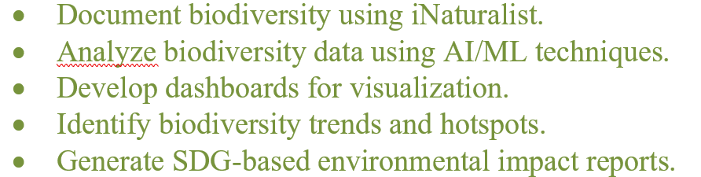
2. Log Book Photo Submission Guidelines:
Answer

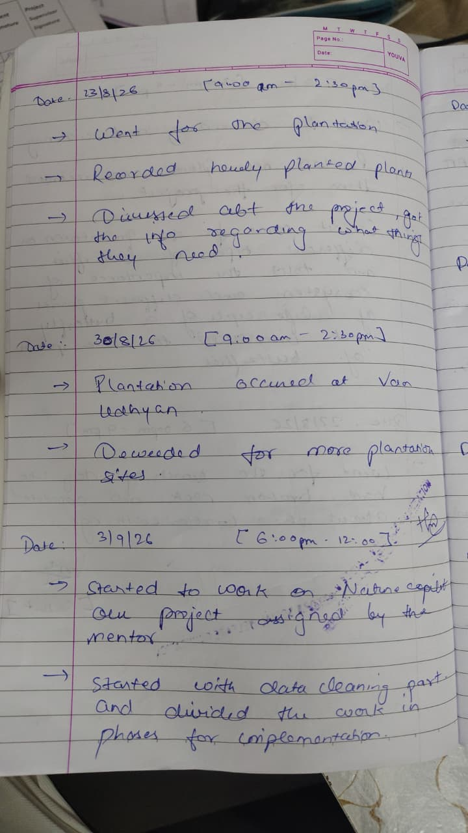
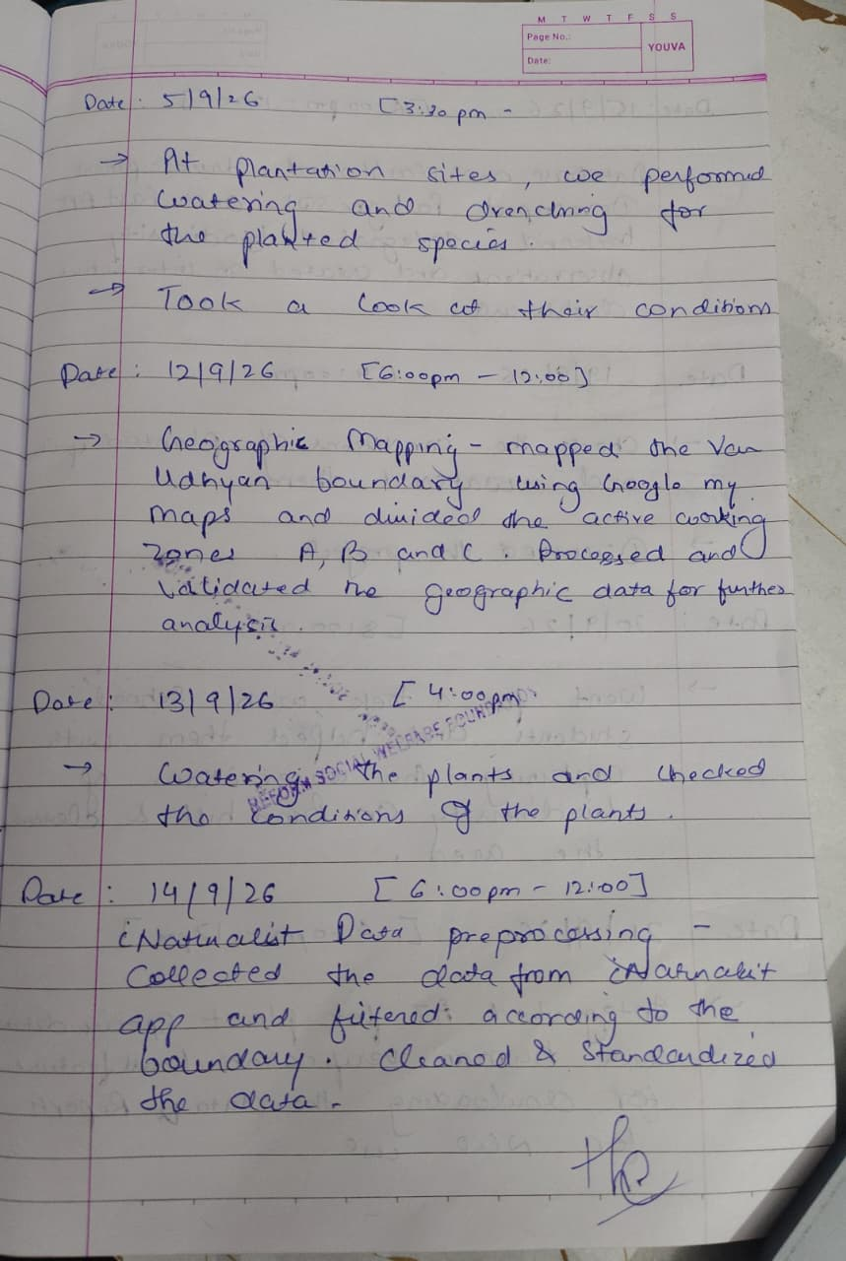
2. Geo-Tagged Photo Submission Guidelines:
Answer
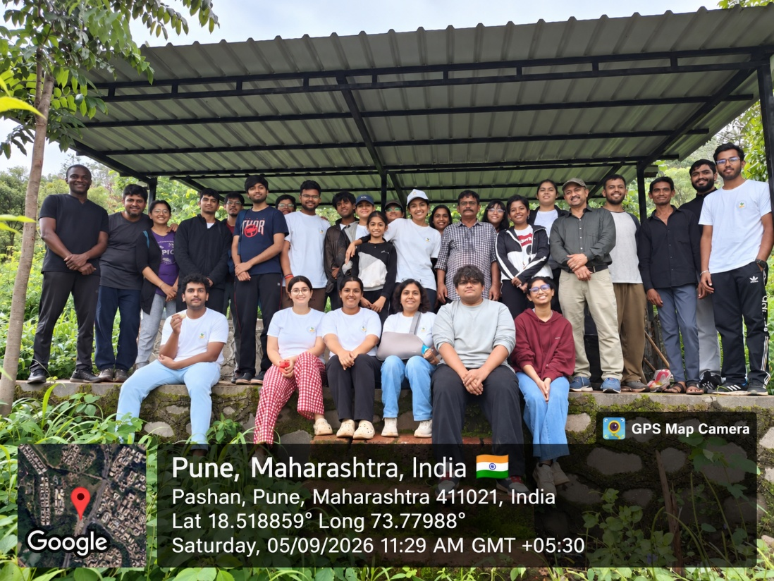

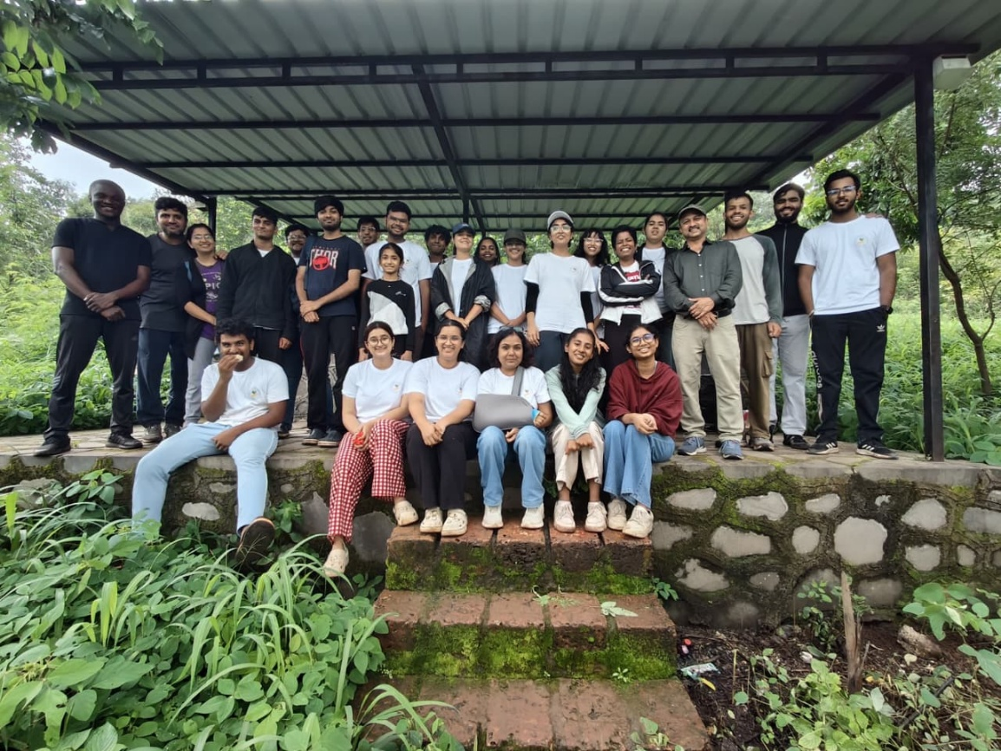

Fig : GROUP PHOTO
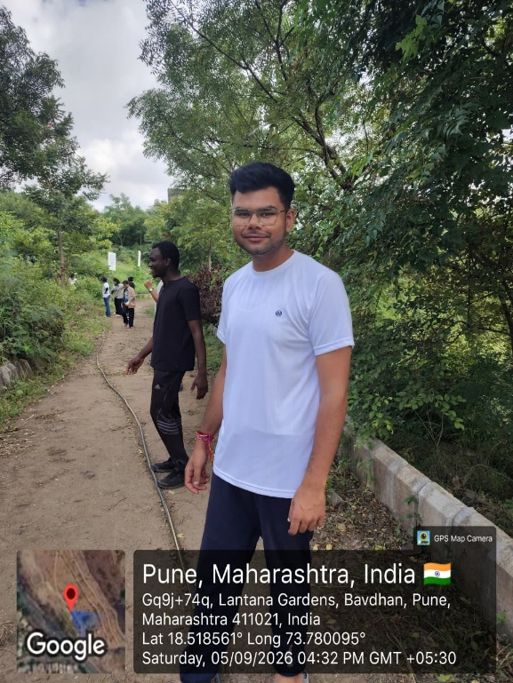FIG : Watering in human chain to the plants
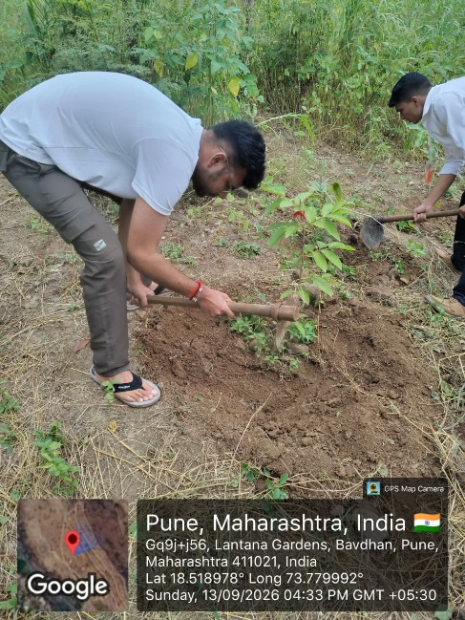FIG : drenching
PROJECT :
